Advanced Telecom Computing Architecture

Jussi Mäki
Helsinki University of Technology
Telecommunications Software and Multimedia Laboratory
P.O. Box 5400, FIN-02015 TKK
FINLAND

Abstract
The telecom infrastructure equipment manufacturer business is an oligopoly because entry barriers to telecom infrastructure equipment market are high. Entry to market requires significant investments to telecom platform. The telecom infrastructure business is facing increasing cost pressure. Advanced Telecom Computing Platform (ATCA) is the first industry standard that specifies basis for an open standards based modular platform, on which Telecommunications Carrier Grade applications can be based on. The effects of ATCA to telecom infrastructure business are studied in this paper by analyzing ATCA implications to telecom infrastructure equipment vendor’s cost structure, market entry barriers, and network operator’s capital and operational expenditures.

Key Words
ATCA, PICMG, Entry Barriers, R&D costs, CAPEX, OPEX.

1. Introduction
Telephone was invented by Alexander Graham Bell in 1876. Since the invention of telephone the manufacturing of telephone exchanges has been done by specialized telephone manufacturing companies. Telephony technology has changed many times after the invention of telephone to this day but the fact that specialized telephone manufacturer’s produce the telephone exchanges has not changed.

The characteristics of the market that the specialized telephone network infrastructure manufacturers produce the telephone network equipment has caused that the industry is an oligopoly with few telecom equipment vendors ruling the industry. One of the main reasons for the oligopoly is that the entry barriers to the market have been high. The main contributor to high entry barriers are the large capital investments required to build a telecom platform. Even a company had the capital to build the telecom platform building of telecom platform is not a trivial because it requires a set of specialized skills. There is also high risk associated to decision to begin to build a telecom platform because if it fails there is low salvage value in half built telecom platform.

Advanced Telecom Computing Platform (ATCA) is the first industry standard that specifies basis for an open standards based modular platform, on which many applications can be built. ATCA is primarily focused on Telecommunications Carrier Grade applications based on standard fabric solutions. ATCA is completely based on commercial off the shelf components. The specifications of ATCA are available for any company. (PICMG 2004)

ATCA is appealing alternative because the telecom infrastructure market is facing increasing price sensitivity. The telecom equipment vendors are seeking ways to lower their R&D to sales ratio. Network operators are seeking ways to lower their capital and operation expenditures. ATCA shows the potential to break the oligopoly of few telecom vendors and increase competition. Furthermore it has the potential to lower the development and production costs of telecom network element thus the whole telecom network. Potentially ATCA decreases also the operational costs of telecom network.

The scope of this paper is to analyze implications of ATCA to telecom infrastructure business mainly from telecom vendor and partly from network operator perspective. First brief overview of ATCA is given. Next the effects on cost structure of telecom infrastructure are analyzed from telecom vendor’s perspective. Then effects on entry barriers to telecom infrastructure market are analyzed from telecom vendor’s perspective. In the next chapter vendor strategies are discussed. In chapter 6 an ATCA based telecom infrastructure product is presented. In chapter 7 network operator view of ATCA is discussed. Finally the conclusions are given.

2. Overview of ATCA standards
Advanced Telecom Computing Architecture (ATCA) is a series of industry standard specifications for the next generation of carrier grade telecommunications network infrastructure equipment. The base ATCA specification, PICMG 3.0, was ratified in December 2002. ATCA standards are developed by PCI Industrial Computer Manufacturers Group (PICMG) that is a consortium of over 450 companies who collaboratively develop open specifications for high performance telecommunications and industrial computing applications. ATCA is targeted to be a common hardware platform for ordinary computing and telecommunications equipment. (Alcatel 2005) (What is PICMG? )

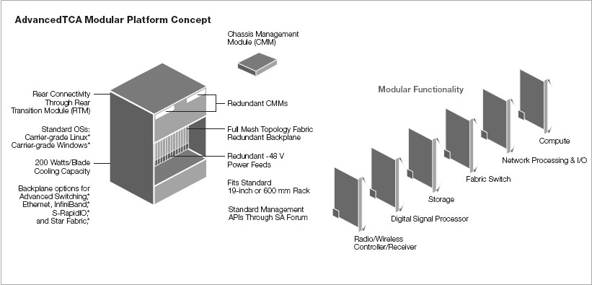
Figure 1. ATCA System Components. (Intel 2004)

Figure 1 illustrates the components needed for ATCA chassis, power supplies, Chassis Management Modules, cooling, backplane and rear transition modules. The modularity of the platform is achieved by selection of the plug-in boards based on application requirements. The ATCA backplane and the management interfaces are standardized and open thus any vendor has possibility to produce ATCA compatible boards. The boards may be tailored to Compute, Network Processing & I/O, Fabric Switch, Storage, Digital Signal Processor and Radio/Wireless Controller/Receiver. There exist various vendors of ATCA chassis components and specific boards. (Intel 2004) (PICMG 2003)

2.1. PICMG 3.0
PICMG 3.0 is the overall general specification that defines mechanics, board dimensions, power distribution, power and data connectors, and system management for ATCA. The specification does not specify the type of switching fabric instead specific fabric definitions will be undertaken on subsidiary specifications from PICMG 3.1 to PICMG 3.6. The component interoperability will be defined by the combined PICMG 3.0 core specification and a subsidiary fabric specification. (PICMG 2006)

2.2. PICMG 3.1
PICMG 3.1 specification defines an Ethernet and Fibre Channel switch fabric over the generic backplane fabric interconnect. It provides data rates up to 10 Gbit/sec. per link. (PICMG 2006) (Unstrung Insider 2004)

2.3. PICMG 3.2
PICMG 3.2 specification defines how InfiniBand systems are built within the architecture and will specify link physical layers, protocols, and protocol mappings. (PICMG 2006) (Unstrung Insider 2004)

2.4. PICMG 3.3
PICMG 3.3 specification defines a StarFabric implementation over the backplane providing TDM, cell, control, and packet connectivity over the same fabric. (PICMG 2006) (Unstrung Insider 2004)

2.5. PICMG 3.4
PICMG 3.4 specification defines how PCI Express and PCI Express Advanced Switching transport is mapped onto the generic backplane fabric interconnect. (PICMG 2006) (Unstrung Insider 2004)

2.6. PICMG 3.5
PICMG 3.5 specification defines how Serial RapidIO transport is mapped onto the generic backplane fabric interconnect. (PICMG 2006) (Unstrung Insider 2004)

2.7. PICMG 3.6
PICMG 3.6 defines how Packet Routing Switch (PRS) is mapped onto the generic backplane fabric interconnect. The specification is still under development. (PICMG 2006) (Unstrung Insider 2004)

3. Implications of ATCA to the cost structures of telecom infrastructure
Traditionally telecom vendors have differentiated their products through the functions of proprietary telecom platform. The Research and Development spending to telecom platform development of telecom vendors have reflected this characteristic of telecom market. When ATCA is introduced the telecom platform is standard so no differentiation is achieved by telecom platform. The overall R&D spending will decrease because of use standard telecom platform. A special report made by RHK (RHK 2003) assumed a cost model where the target cost per board could be reduced by up to 60% in four years compared to the proprietary boards/equipment model.

Figure 2 shows the change in costs structure of telecom infrastructure. The R&D spending for proprietary hardware and software platform decreases because commercial processors and building blocks are used thus less testing and in house development is needed. The costs saved in platform development leave room for innovativeness in application software and features.

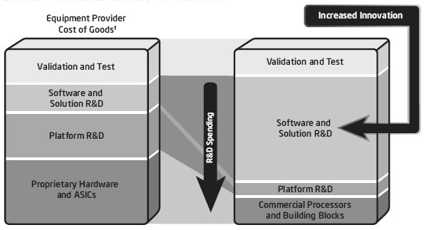
Figure 2. Benefits of standard based platform (Intel 2006)

ATCA pushes the telecom industry from traditional vertical production model, in which telecom vendors makes everything in house, to vertical production model, in which telecom vendor buys the standard components from another company. The move from proprietary in house design to purchase standard hardware and components leads to greater rationalization of the telecommunications market, as the same R&D spending from one ATCA hardware vendor can be capitalized by several telecommunications vendors. This results in increase of manufacturing volumes and results in lower prices. Figure 3 illustrates the move form vertical to horizontal production model. (Alcatel 2005)

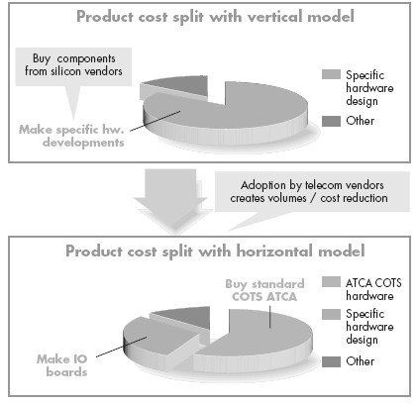
Figure 3. From Vertical to Horizontal production model (Alcatel 2005)

Telecom vendors should not concentrate their R&D spending on parts that do not add differentiation, the standard ATCA components, because they can be bought from any of the multiple hardware vendors. There are numerous ATCA component vendors thus low cost can achieved by competition. Telecom vendors should concentrate their R&D only to the parts that add differentiation to their products e.g. specific I/O boards or user plane processing hardware. (Alcatel 2005)

4. Implications to entry barriers of telecom infra markets
The implications to entry barriers of telecom infrastructure market are analyzed using Threat of Entry force from the Michael Porter’s five competitive forces framework. The analysis is made from telecom vendor perspective.

4.1 Economies of Scale
Economies of scale are required for development and production of telecom infrastructure network elements to achieve competitive cost structure. Telecom platform constitutes large fraction of the development and production costs of a network element.

The development costs of ATCA platform will be shared by many of the manufacturers of telecom network elements thus limited investments in development are required to obtain a telecom platform. The production costs for the telecom platform will also decrease because the economy of scale is not limited to a single vendor but economies of scale will be industry wide.

4.2 Product Differentiation
Today telecom network element products are not differentiated by the set of features because they are mainly based on standards but proprietary platform functions like sophisticated Operation and Maintenance interface. However the need for feature differentiation i.e. introduction of add on proprietary features is increasing because network operators are demanding for proprietary extensions to help their task to build differentiated services.

The ATCA platform will be standard component thus the differentiation of telecom network element must be achieved by rich set of application features. The modularity of ATCA gives possibility to plug-in application specific boards into ATCA chassis. This is an enabler for product differentiation.

4.3 Capital Requirements
Today capital requirements for market entry are high because large initial investment for the development of proprietary platform for network elements is needed. Furthermore there is low salvage value in half built telecom platform.

The initial high capital investment will no longer exist because the ATCA telecom platform is available for everyone.

4.4 Switching Costs
Customer switching costs are high because switch to another supplier requires not only replacement of the equipment but also extensive training operator’s personnel. The training is required because the hardware and operation & maintenance of proprietary platform are vendor specific.

ATCA will lower the customer switching costs because same hardware and management interfaces are used among all vendors. Thus it is easier to switch from one supplier to another.

4.5 Access to Distribution Channels
Incumbent players have established relationships between the customers, network operators, thus they have advantage over new entrants. However the effect of long term relationships between suppliers and customers is decreasing because the shareholders are expecting to get more and more profit. This causes that the telecom network elements are more often purchased based on lowest bid. This entry barrier is already today low and ATCA should not have significant impact on it.

4.6 Cost Advantages Independent on Scale
Telecom industry has a long history with Intellectual Property Rights. The large vendors have agreements between each other to share Intellectual Property Rights. However in telecom platform area the number of protected assets is low.

ATCA is an open standard and the technologies used in technical realization of it are open thus there should be no barriers with Intellectual Property Rights.

4.7 Government Policy
In high penetration markets e.g. Europe governments are not regulating the market and competition is open thus government policy does increase the entry barriers. In some low penetration countries the governments are by legislation regulating the entry to market. By requiring extensive tests on network elements until license to market is granted. Or by requiring the network element production is done in the market it is sold otherwise high protection toll must be paid. ATCA should not have significant impact on this entry barrier.

5. Vendors' strategies
In the recent years Research and Development spending has been high and continuously increasing in many telecommunication manufacturing companies that has affected negatively to profitability of the companies. One of the main reasons for this has been development of many telecommunication node platforms [Nokia Corporation 2005]. ATCA has the potential to decrease R&D spending for the telecom platform. However not all telecom vendors see ATCA as potential but threat. This is because two main factors:
1. They have made significant investments to their proprietary telecom platform. ATCA might cause them to loose the capital investments.
2. They have substantial market share and are making profit from the sales of proprietary platform based network elements. ATCA might decrease their market share and profit.
Because of the two above factor vendors have selected different strategies.

Market leaders e.g. Nokia, Ericsson are continuing investments to proprietary platform because ATCA has not affected so far to their sales. They are actively following up the market, customers and participating in ATCA standardization but have not launched products based on ATCA. The market leaders are most probably looking into possibilities to evolve into ATCA in order to be ready when/if ATCA start to affect their sales but are doing this in secret.

The telecom vendors that do not have as large market share as the market leaders e.g. NEC, Alcatel are interested on ATCA and see ATCA as possibility to challenge the market leaders by means of differentiation. They have launched ATCA based products [NEC 2003] or have announced that they will release ATCA base products in near future [Alcatel Press Release 2005].

ATCA will enable new vendors, even small ones, to enter the market e.g. Ulticom [Ulticom 2006] and Iskratel [Iskratel 2006]. New entrants will probably select low cost strategy utilizing the increasing price pressure in the telecom market because they have more competitive cost structure.

6. NEC’s ATCA based SGSN and GGSN
NEC launched world's first Serving GPRS Support Node (SGSN) and Gateway GPRS Support Node (GGSN) network elements that are based on ATCA in September 2003. Today more than 150 of them are already up and running in different commercial networks. The NEC’s ATCA-based platform also employs carrier-grade Linux and NEC proprietary middleware. The high carrier-grade reliability and capabilities are offered by NEC’s middleware. NEC launched the ATCA based platform to achieve a short-term product development period (1/3 of current systems), and drastically reduce product development costs by utilizing open software/hardware. The ATCA based platform realizes rich services for carriers with carrier-grade reliability, easy operation, and high cost performance. Figure 4 illustrates the NEC platform architecture. (NEC 2003) (NEC 2006)

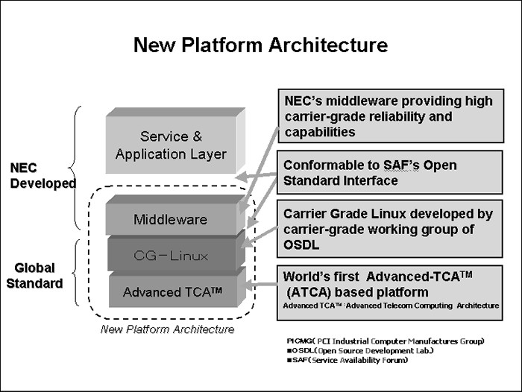
Figure 4. NEC Platform Architecture(NEC 2003)

NEC was the first in the market to launch ATCA based network element however it has not drastically boosted its overall sales (NEC 2005). NEC wisely selected GGSN and SGSN network elements to be the first network elements to utilize ATCA because they are quite new network elements compared to some other elements in the telecom network. Thus there are lower customer switching costs and less legacy dependencies associated to SGSN and GGSN that would hinder the sales.

The NEC product strategy from proprietary platform to ATCA seems like evolutionary step. ATCA based SGSN and GGSN is continuation of their traditional SGSN and GGSN product line. This is because if they would have made more revolutionary step the product would have not been ready so early. Also the utilization of proprietary middleware indicates that an evolutionary path is selected. By selection of evolutionary path NEC can benefit from the previous capital investments to the development of network element.

7. Operators
The incumbent network operators are today highly focused on how to decrease the Capital Expenditures (CAPEX) and Operational Expenditures (OPEX) in their operations because of the price pressure especially in voice services. ATCA offers the potential to decrease both CAPEX and OPEX of network operators. ATCA effects to CAPEX and OPEX of network operators are listed below
CAPEX:
- Development and production costs of ATCA based nodes are cheaper this should result lower purchasing cost per network element. In (Unstrung Insider 2004) it is stated that according to Intel executive it is possible to cut up to 35% of capital expenditures.
- Evaluation of products from different telecom vendors becomes cheaper and easier. Risk of making wrong choice decreases.
OPEX:
- Supply chain will be unified that will improve manageability of supply chain, reduce spare part inventory, reduce repair costs and improve on-site maintenance capabilities.
- Reduction in training costs because less training needed for the network operation and maintenance personnel and fewer specialists needed to service a mixture of varying proprietary hardware architectures.
- Consistency in human interfaces and operation of systems around the network that enables greater efficiencies in overall operating processes
- Uniform network element layouts and maintenance practices will decrease labor costs.
- Smaller footprint and reduced power consumption will decrease rental and electricity costs.
(Alcatel 2005) (Intel 2004)(Unstrung Insider 2004)

Even ATCA shows the potential to decrease CAPEX and OPEX the incumbent operators that have recently made significant investments to network infrastructure are not rushing to ATCA because they want to utilize the already made investments to the network infrastructure. Thus ATCA based nodes will not be common in incumbent operator’s network until the next network modernization phase e.g. (British Telecom 2004) or next generation mobile system is launched.

However the Greenfield operators are interested on ATCA based nodes because ATCA offers them significantly smaller CAPEX and OPEX compared to incumbent operators, their competitors. They can enter the market with smaller capital investments and they can select the cost leadership strategy exploiting lower OPEX to conquer the market.

8. Conclusion
ATCA enables costs rationalization from both telecom vendors and network operators and thus is an answer to increasing market price sensitivity. ATCA enables telecom vendor’s to lower their R&D to sales ratio and it enables network operators to lower the capital expenditures and operational expenditures. ATCA substantially lowers the entry barriers to telecom equipment infrastructure market thus it will break the traditional oligopoly of network equipment infrastructure market. This causes more competition in the market and lowers price levels.

However the telecom infrastructure market leaders are still waiting to see will ATCA take off. They are continuing development of proprietary platforms and the incumbent network operators are continuing investment on equipments based on proprietary platform. If ATCA takes off the market leaders should introduce the ATCA as a continuation of their existing product line because they can benefit from the previous capital investments to the development of network element. First ATCA based network elements could be packet core nodes GGSN and SGSN because the customer switching costs are lower in those nodes.

The new entrants in both equipment vendor and operator markets have the momentum to attack the market leaders now by quickly introducing ATCA based products and networks. They can utilize the substantial cost benefits as the weapon.

References
Alcatel 2005.
AdvancedTCA™ – “A common platform concept to improve product engineering”. Strategy White Paper. http://www.alcatel.fi/com/en/appcontent/apl/S0705-ATCA-EN_tcm172-295201635.pdf
Alcatel Press Release 2005. Alcatel and Sun Microsystems sign major cooperation agreement on core network solutions. Press release. http://www.home.alcatel.com/vpr/vpr.nsf/AllDocuments/2EB769BA88153B9FC12570A5002F88F5?openDocument
British Telecom 2004. BT to switch voice calls to IP as 21st century network takes shape. Press release.
http://www.btplc.com/news/articles/showarticle.cfm?articleid=b80dbd58-a821-46d8-9852-81e1cab365dd
Intel 2004. Advanced Telecom Computing Architecture: Enabling accelerated deployments of innovative services while reducing OpEx. White Paper http://www.intel.com/design/network/papers/30265401.pdf
Intel 2006. Accelerating the Transformation Intel’s Leadership in Embedded Communications and Networking Maximizes Innovation and Choice for Network-Centric Warfare. White Paper http://download.intel.com/design/embedded/papers/31184701.pdf
Iskratel 2006. Building up and Connecting Networks http://www.iskratel.si/sites/PRODUCTS_en/doc/posebne/main/concept_en.pdf
NEC 2003. NEC to Launch World's First, Advanced New Platform for Mobile Operators Employing PICMG Forum Advanced-TCA(TM). Press Release. http://www.nec.co.jp/press/en/0309/1001.html
NEC 2005. Annual Report 2005.
http://www.nec.co.jp/ir/en/library/annual/2005/pdf/ar2005-e.pdf
NEC 2006.
Product description: Packet Core Node http://www.nec-mobilesolutions.com/infrastructures/products/packet.html Referenced 9.4.2006.
Nokia Corporation 2005. Form 20-F 2005. http://www.nokia.com/NOKIA_COM_1/About_Nokia/Financials/nokia_form_20f_2005.pdf
PICMG 2003. PICMG 3.0 Short Form Specification. http://www.picmg.org/pdf/PICMG_3_0_Shortform.pdf
PICMG 2004. ATCA Tutorial. http://www.picmg.org/pdf/Supercomm_Tutorial.pdf
PICMG 2006.
PICMG Specifications. Revision 2.7. http://www.picmg.org/specifications.stm Referenced 9.4.2006.
RHK 2003. The Outlook for AdvancedTCA Platform and Blades. Special Report. http://www.picmg.org/pdf/RHK_ATCA_Whitepaper_FINAL.pdf
Ulticom 2006.
Ulticom Launches nSignia Signaling Gateway. Press release. http://www.ulticom.com/html/investors/press-releases-detail.asp?ID=139
Unstrung Insider 2004. ATCA for 3G wireless Networks. Vol. 3, No. 12, December 2004.
What is PICMG? http://www.picmg.org/aboutus.stm Referenced 9.4.2006

